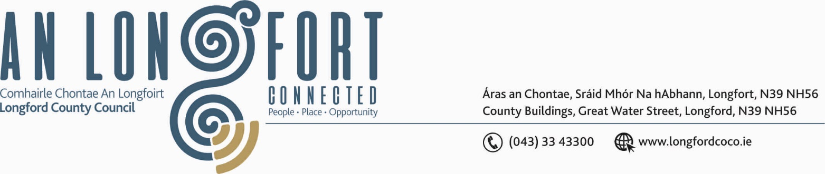

BALLYMAHON MUNICIPAL DISTRICT

Please note Meeting will be held using Microsoft Teams

1st April 2020.

To: Each Member of Ballymahon Municipal District.

Dear Member,

You are requested to attend Meeting of Ballymahon Municipal District to be held, using Microsoft Teams, on Tuesday, 7th April 2020 at 3.30 p.m. to transact business, as set out on the Agenda hereunder.

Yours sincerely,
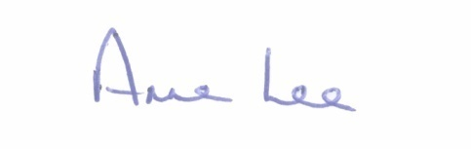

_______________
Anne Lee,
Meetings Administrator.

AGENDA

Prayer before meeting.

1. Confirmation of Minutes of Ballymahon Municipal District Meetings held on the 23rd January and 14th February 2020 - copies enclosed.

2. Matters arising from Minutes.

3. Declaration of Interest by Members.

4. Consideration of applications for funding under the 2020 Community Grant
Support Scheme - list enclosed.

5. Consideration of applications for funding under the 2019 Community Grant
Support Scheme.

